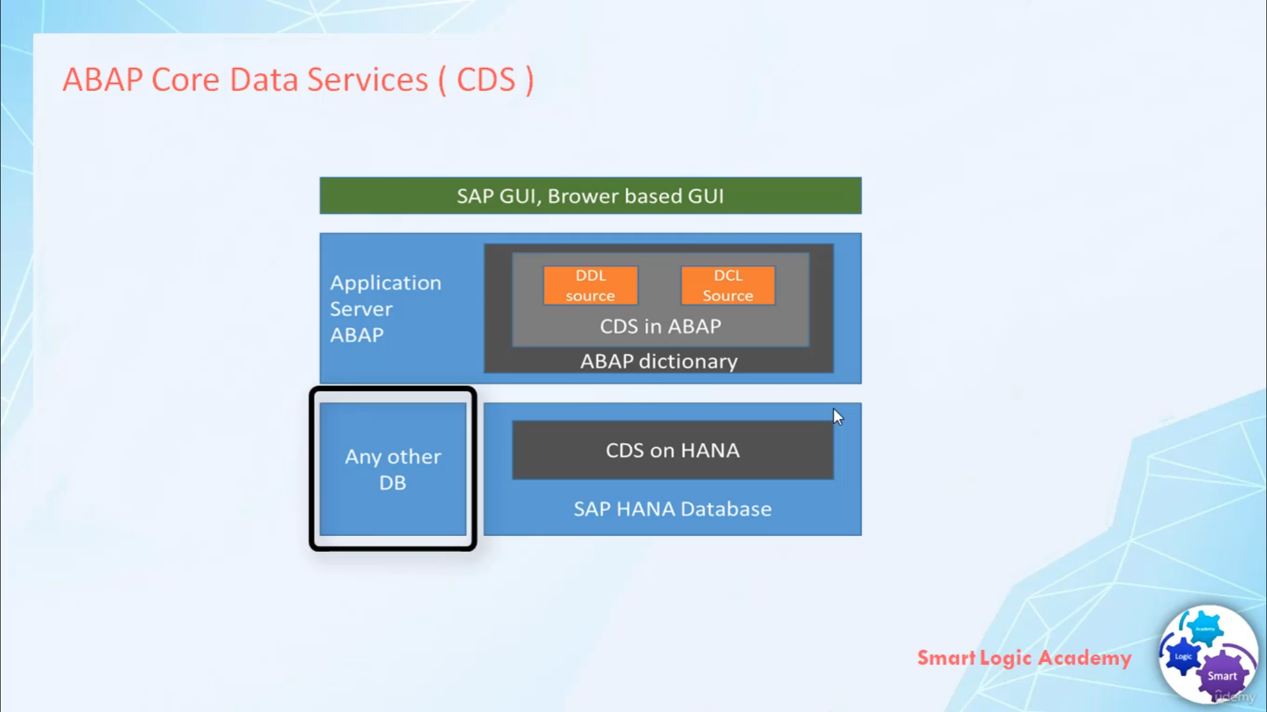

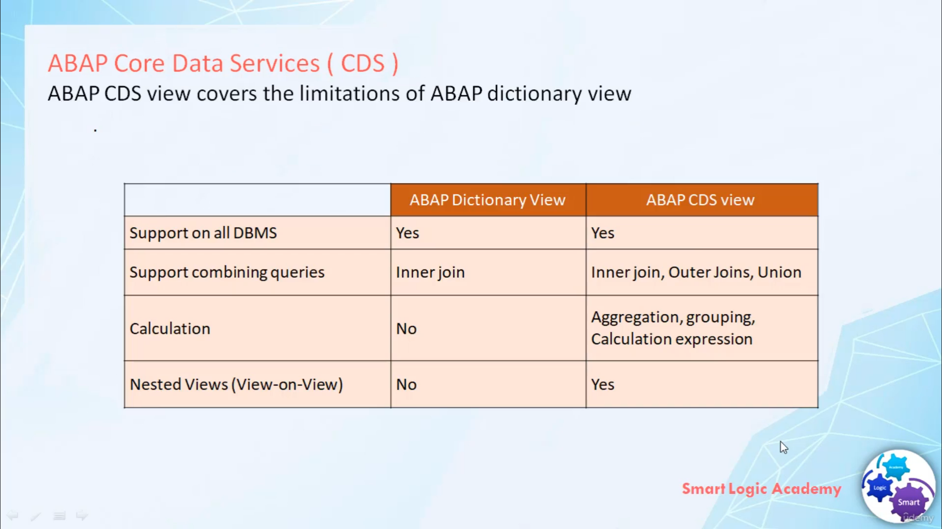

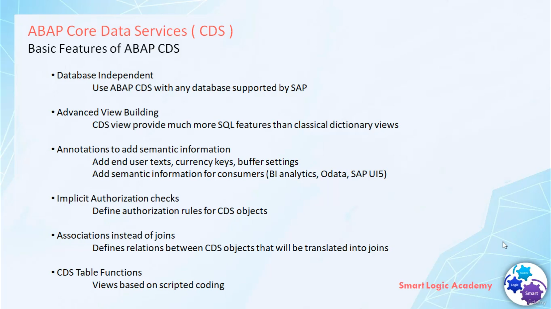

Hi,

welcome back.

I hope you have understood what CDS, what is SAP HANA, Code-Push-Down approach and why we

need new OPEN SQL syntax. After covering the background.

Now I would like to start with the main topic of this course

that's nothing but ABAP Core Data Services.

from the beginning, ABAP Core Data Services was not designed for SAP HANA database alone. ABAP Core Data Services

support all types of the database. since the ABAP Dictionary with its capability of defining TABLES, VIEWS

and DATA Types was already there

nature way of introducing Core Data Services on the ABAP application server was to add it to the

ABAP Dictionary.

The new ABAP repository objects DATA DEFINITION (DDL Source) and ACCESS CONTROL

(DCL Source) both allow you to push more data-intensive calculations to the database which was simply not

possible using classical ABAP dictionary views.

You can use ABAP CDS view to read data and calculate additional information while reading that

data.

One point you have to remember here, ABAP CDS views do not support data modification.

That means you can use ABAP CDS to read data but you can't use ABAP CDS to write data.

Ok now let's see, what are the limitations of basic ABAP Dictionary view and how the ABAP CDS view

overcome these limitations.

both views ABAP Dictionary view and ABAP CDS view support all database management system.

ABAP Dictionary view support INNER JOIN for combining queries whereas ABAP CDS views to support INNER JOIN,

OUTER JOIN and UNION for combining queries.

ABAP Dictionary views do not support any kind of calculation

whereas ABAP CDS views support Aggregation, Grouping and Calculation Expressions means when you use ABAP

Dictionary view you simply read data from database table and project it to the presentation server. whereas

in case of ABAP CDS view, when you read data from database table you can process on it using Aggregation

and Calculation Expression and after calculation resulting set you can display. ABAP Dictionary

view not support NESTED VIEW means you can't use one view to form another view. whereas ABAP CDS view

support NESTED VIEW means you can use one view to form another view.

Now let's discuss about the basic features of ABAP Core Data Services

ABAP CDS views are database independent.

that means you can use ABAP CDS view with any database supported by SAP. ABAP CDS view

provides much more SQL features than classical dictionary view. for example Calculation Expressions

ABAP CDS view supports ANNOTATIONS. Using ANNOTATIONS

you can add more semantic information to Core Data Services. for example Currency Key, Buffer settings.

ABAP CDS view support implicit authorization checks. you can use new repository object DCL Source

to define authorization rules for CDS objects.

In ABAP CDS view you can use ASSOCIATIONS instead of JOINS

to define relation between CDS objects.

ASSOCIATIONS are called as dynamic JOINS because they're translated into JOINS based on user

SELECT query. ABAP CDS view supports CDS TABLE FUNCTIONs to create views based on scripted coding.

Here we use

ABAP Managed Database Procedures to create CDS views.

That's it for now,

I hope you have understood the theory.

Have a nice day.